Basic Adapters

"Adapters are the link between a set of data and the AdapterView that displays the data.

AdapterView
AdapterViews are ViewGroups that display child views given to it by an adapter. An example of an AdapterView is a ListView.
Adapters also provide the child views that display the data in the AdapterView. Adapters are responsible for supplying the data and creating the views representing each item."
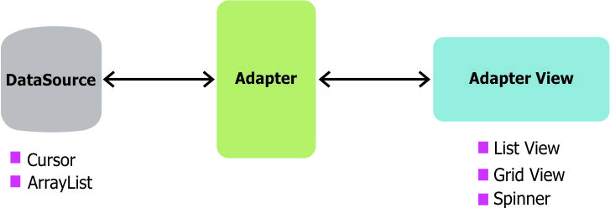
https://github.com/codepath/android_guides/wiki/Using-an-ArrayAdapter-with-ListView

Adapters are the interface through which information is displayed into the various more advanced views of antroid, such as ListViews and GridViews. Whilst ListViews and GridViews have a lot going on as raw UI elements they are relatively low on inherent intelligence so the Adapter acts as a buffer between the raw UI element and the rest of the code, ensuring that the inforamtion is displayed properly. The data being fed into the List or Grid will also come from some source like an array or a list, and the adapter can be passed these entire data structures and will then handle extracting information from them and displaying it line by line.

For example, simply adding elements to ListViews and Gridviews can lead to very inefficient use of memory, one of the adapters main jobs is to make sure that only currently visible elements are loaded into memory, and recycles the rows of say a ListView as the user scrolls up or down the screen.

At this level of complexity (like with a standard ListView with a standard array string as a data source) you can use the standard adapters offered by Android. See below:

ArrayAdapter
An ArrayAdapter is an adapter backed by an array of objects. It links the array to the Adapter View.

SimpleCursorAdapter
The SimpleCursorAdapter links the data contained in a Cursor to an Adapter View.

Cursors: A cursor is a set of data. You usually get a cursor when you do a database query. The result of your query is contained in the cursor.

CursorAdapter
A CursorAdapter links a Cursor’s data to a List View. You must include the database’s _id column as it’s used in processing the list item’s selection.
The SimpleCursorAdapter is a subclass of CursorAdapter.

SimpleAdapter
The SimpleAdapter links static data to views defined in a layout file. You specify the data as an ArrayList of Maps. Each entry in the ArrayList will display as a row in a list.

BaseAdapter
The BaseAdapter is a common base class for an Adapter that can be used in a ListView and a Spinner.

ListAdapter
The ListAdapter links the data and a ListView displaying the data. The List View can display any data type provided it’s wrapped in a ListAdapter.

Setting up the adapter

Using the adapter
First define the adapter
ArrayAdapter<String> itemsAdapter =
new ArrayAdapter<String>(this, android.R.layout.simple_list_item_1, items);

Then assign the adapter:

ListView listView = (ListView) findViewById(R.id.lvItems);
listView.setAdapter(itemsAdapter);

Finally when the data set linked to the adapter has been changed, you need to seperatedly notify the Adapter of this:
itemsAdapter.notifyDataSetChanged();

Advanced Adapters and Custom Adapters
ListViews and Gridviews can also be extended however, for example a Listview can have images and multiple lines of text, or a Gridview could have a title below each image. These will require customizing the Adapter to handle this. Its also possible that more advanced data structures might be used, for example an array of objects might be passed, each object containing various fields of data. This is a good simple example extending an Array adapter for a listview:

public class ListAdapter extends ArrayAdapter<Item> {

public ListAdapter(Context context, int textViewResourceId) {
super(context, textViewResourceId);
}

public ListAdapter(Context context, int resource, List<Item> items) {
super(context, resource, items);
}

@Override
public View getView(int position, View convertView, ViewGroup parent) {

View v = convertView;

if (v == null) {
LayoutInflater vi;
vi = LayoutInflater.from(getContext());
v = vi.inflate(R.layout.itemlistrow, null);
}

Item p = getItem(position);

if (p != null) {
TextView tt1 = (TextView) v.findViewById(R.id.id);
TextView tt2 = (TextView) v.findViewById(R.id.categoryId);
TextView tt3 = (TextView) v.findViewById(R.id.description);

if (tt1 != null) {
tt1.setText(p.getId());
}

if (tt2 != null) {
tt2.setText(p.getCategory().getId());
}

if (tt3 != null) {
tt3.setText(p.getDescription());
}
}

return v;
}

}

When declaring a custom adapter you must override the getView function. This is called each time the Adapter tries to display a new item to the listview. Array adapter will already work out depending on the number of items of the source data and user scrolling etc which items these will be, you just need to make sure the line views inside the listview will display as you want them too. You'll be passed the Views position and a view object containing that view as well. Last it will also be passed an object containing the main custom listview/gridview itself.

It's up to you to check to see if the view is new and if it is (eg its null) then it needs to be inflated.

Generally speaking you will be extending one of the basic adapter types given above when you declare a custom adapter eg:

public class ChatListAdapter extends ArrayAdapter<UserProfile> {

